Paper title
Author: Name
Institution : Lab and University for example, City, Country.
Tags: Choose 5 #tags including at least 3 from the list here + 2 of your own choice.
Abstract: 150 word maximum.
A copyright-free image is inserted here to be highlighted when publishing online, extension .JPEG, .PNG or a .GIF for example.

Short paper: 3500 words.
Long paper: 8000 words.
The article is between 10,000 and 30,000 characters including spaces.

- Title
The article is written in Arial 12. The main title, headings and subheadings are in body 26, 18 and 14 respectively. The title of the paper is followed by the name of the author and his laboratory or institution, a maximum of 5 keywords and an abstract of about 150 words. As this is a format intended for publication on a website, the notes and references appear at the end of the document [1]. Words to be highlighted on the webpage are underlined in blue within the text.
- Title
Long quotations are inserted as follows:
In the style called "citation" and with an indent. This quote is two sentences long. [2]
For bibliographic references (Zotero), please use the same system of bookmarks and hyperlinks as used above [3].

2.1. Subtitle
Illustrations, tables or other copyright-free media will be centered with a caption, as follows:
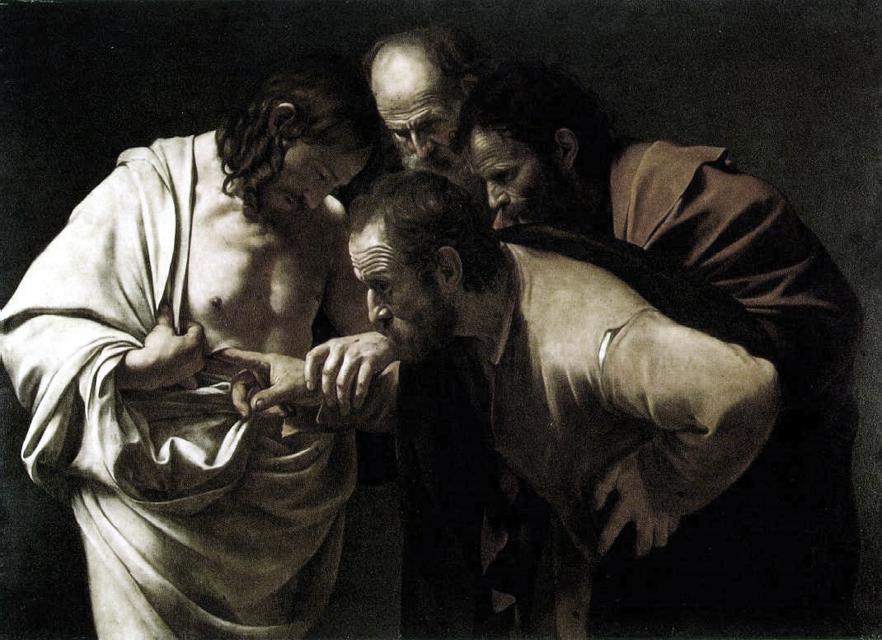
Figure 1 Caravaggio, M. M. da. (1603). L’incrédulité de Saint Thomas [Huile sur toile].

This is a template intended to facilitate the homogeneity of the articles published on DNArchi. However if it’s necessary, it can be adapted.

Notes & References
[1] This is the end of the document and this is a hyperlink with a bookmark, Arial Narrow 10.
[2] This is a quote. To insert the hyperlink, as before, I select the footer phrase and add a bookmark that (here simply named "quote"). Then I select the reference in the body text above, and finally add the hyperlink (check location in this document).
[3] Reference style: Smith, P. D. (1994). Blast and Ballistic Loading of Structures. Oxford, Boston: Butterworth-Heinemann.

